

User Manual
Helpdesk Module
www.flowhcm.com



Contents
Ticket Request 3
Ticket Resolution 7
Ticket Involvement 10
Helpdesk Setting 12
Ticket Category 13
Ticket Group 14
Ticket Type 15
Ticket Status 17
Ticket Priority 18

Ticket Request

- Navigate to Others Tab and click Helpdesk Module
- For Ticket Request, click on Add Ticket Request
- Select the employee from dropdown and enter Ticket Title
- Select the category, Type and Priority of the ticket from dropdowns
- Enter description for the ticket and upload attachment if required then submit the request
- The system will also show Ticket History of the selected employee
- The User can see the requested Ticket in the grid, go on action button to view the ticket or cancel the request
- Ticket Request screen has a brief dashboard as well, click on Show Status Bar

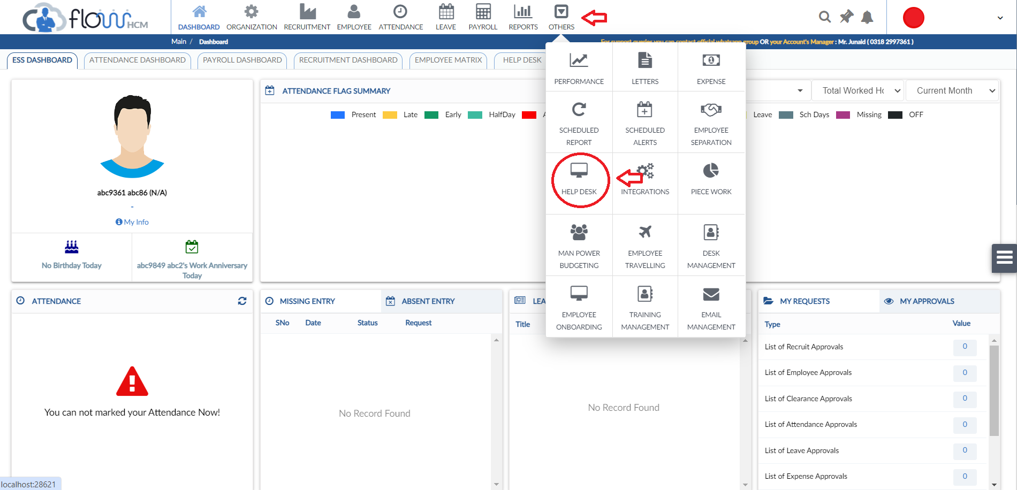
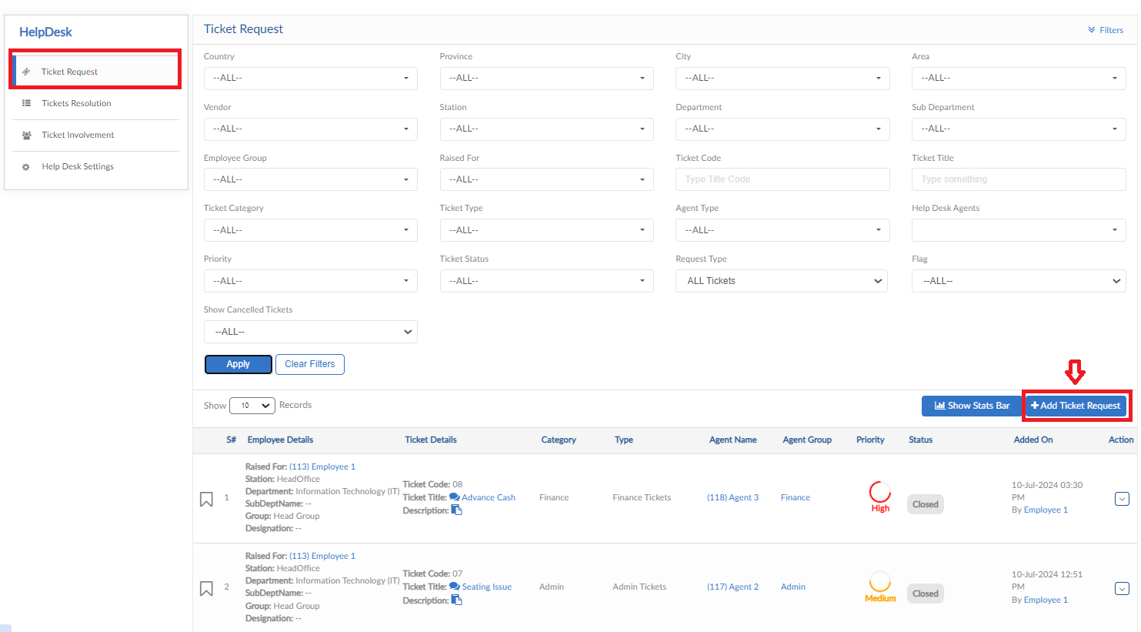
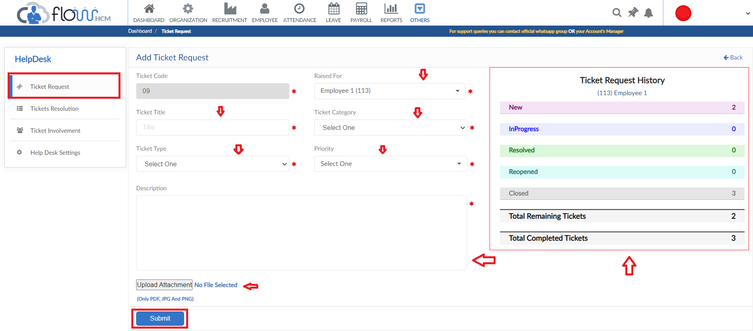
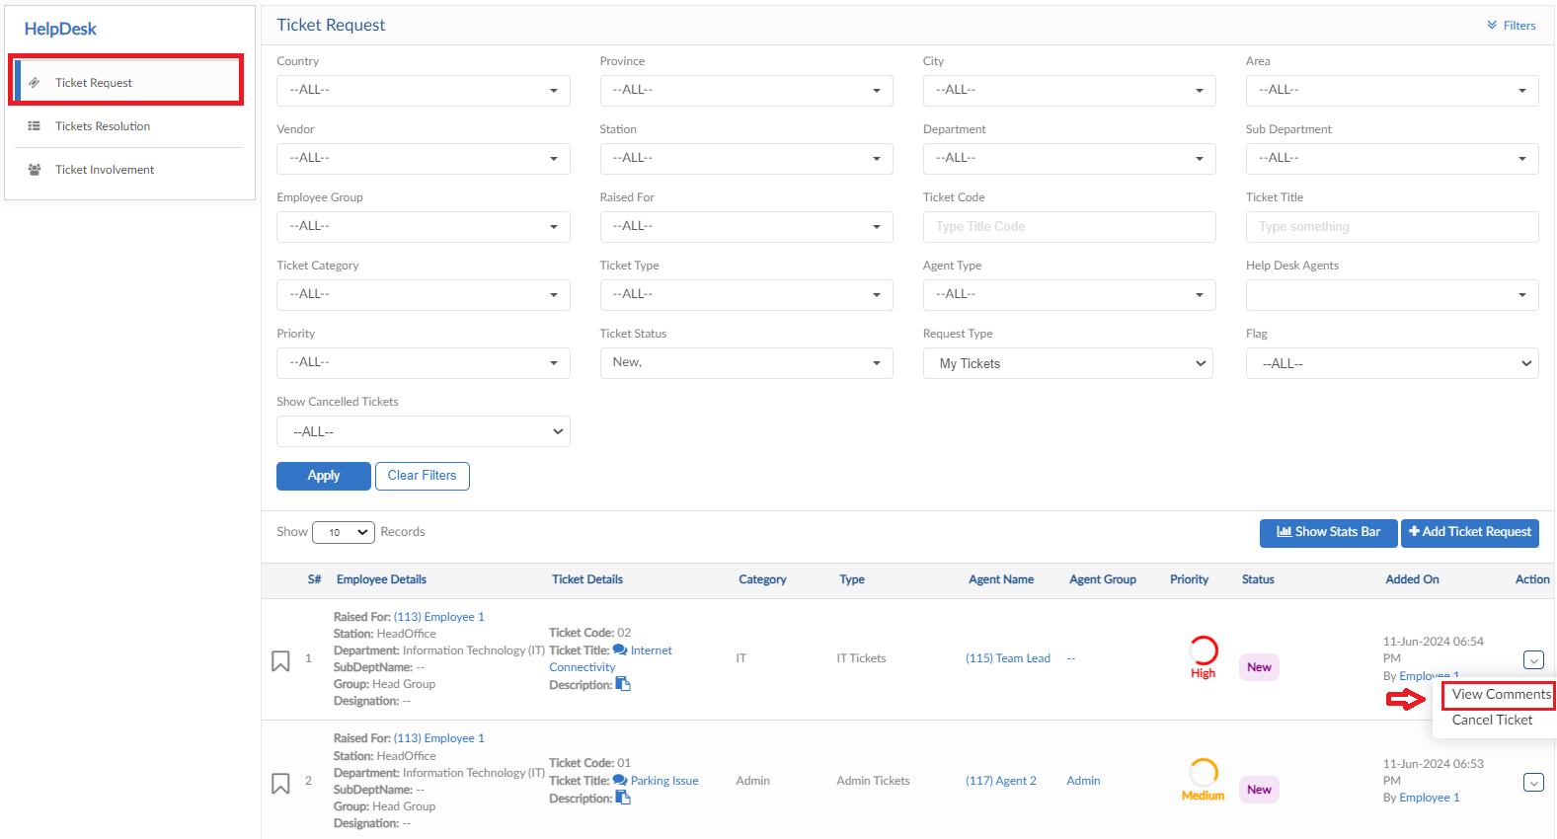
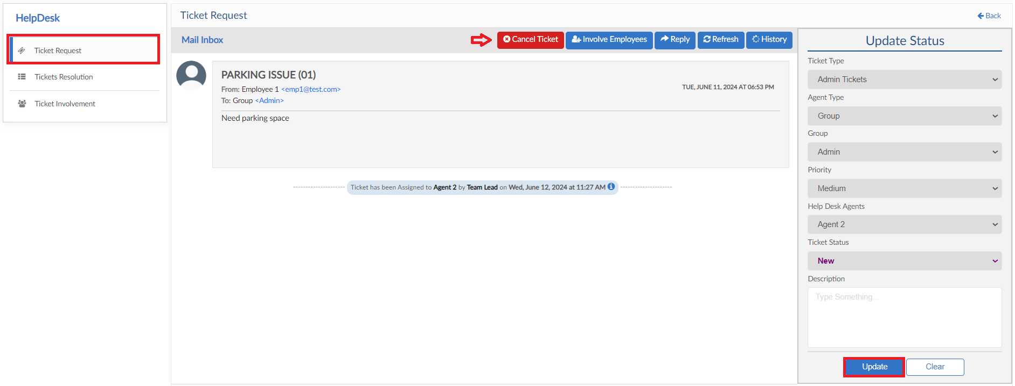

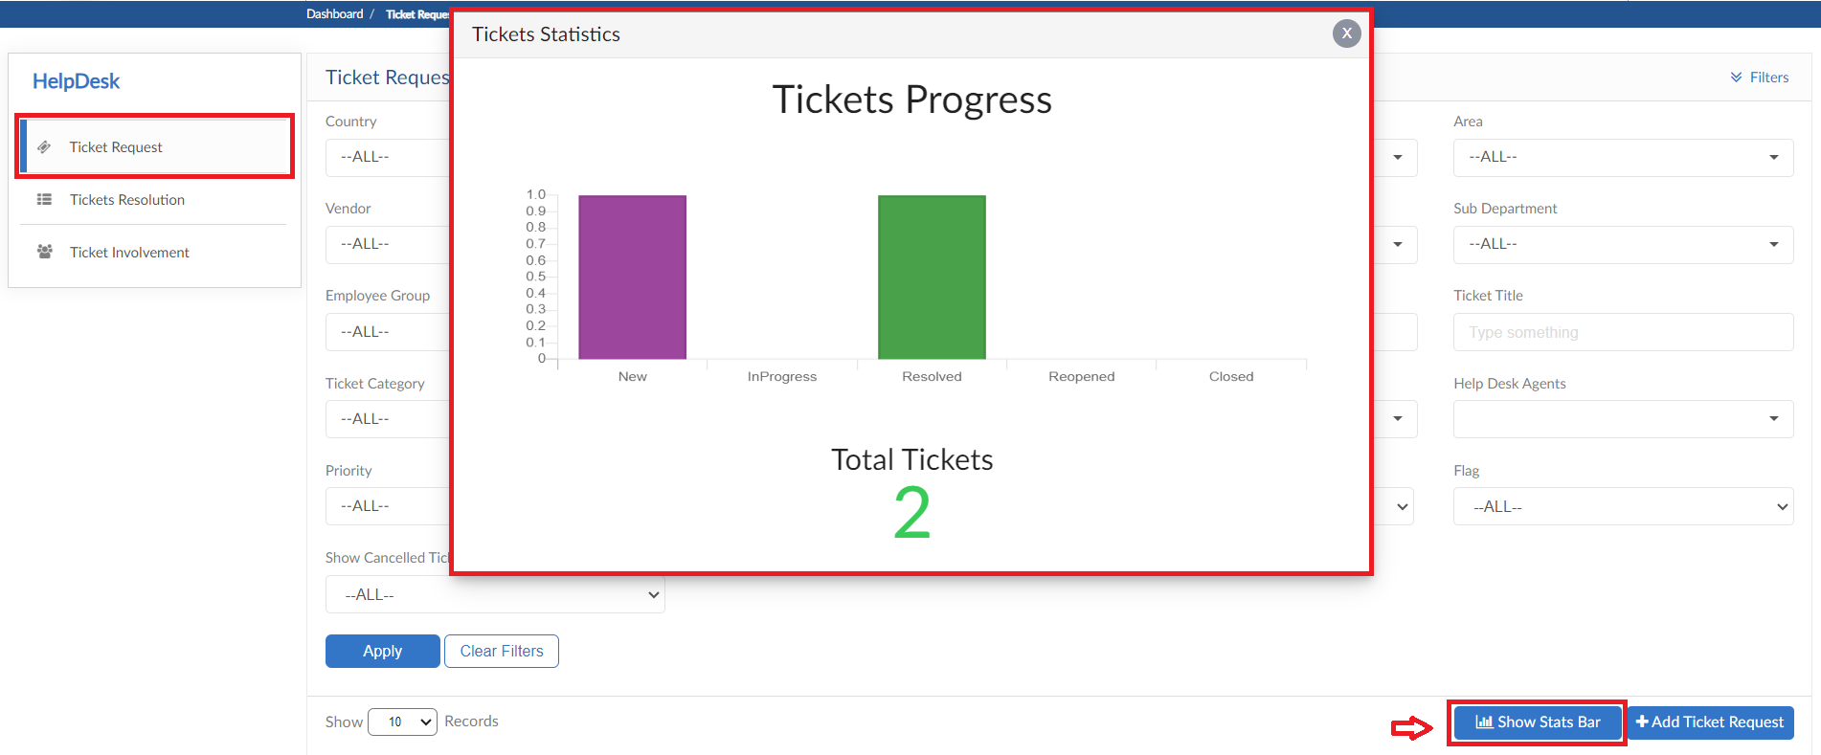

Ticket Resolution

- Move to next tab of Ticket Resolution
- This screen is for the agents to resolve the assigned tickets
- Click on Action button to view the ticket
- Agent can change the Ticket status, add a description and also reply to the requester
- Reply functionality contains tagging employees that part of that ticket
- Ticket Resolution screen also has a Status Bar dashboard
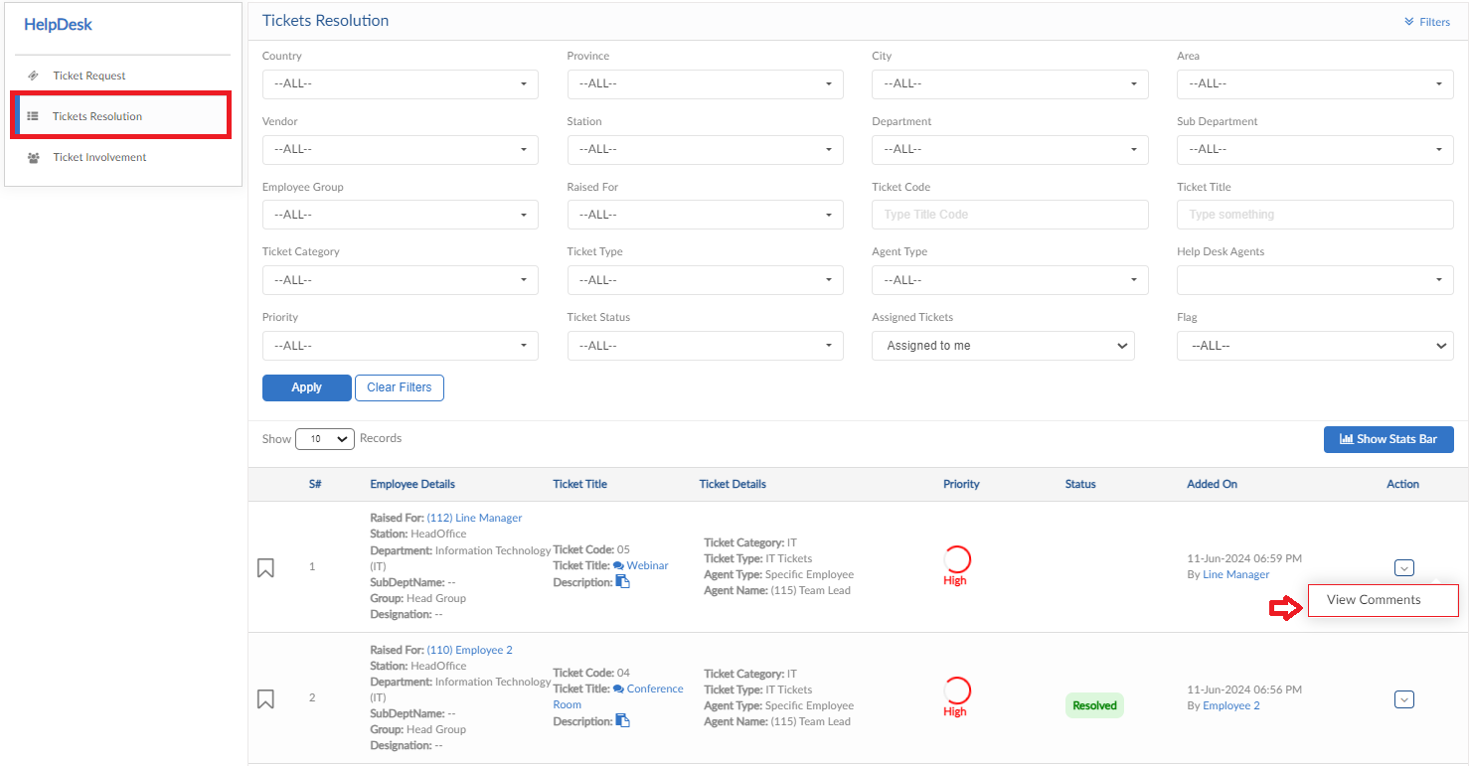
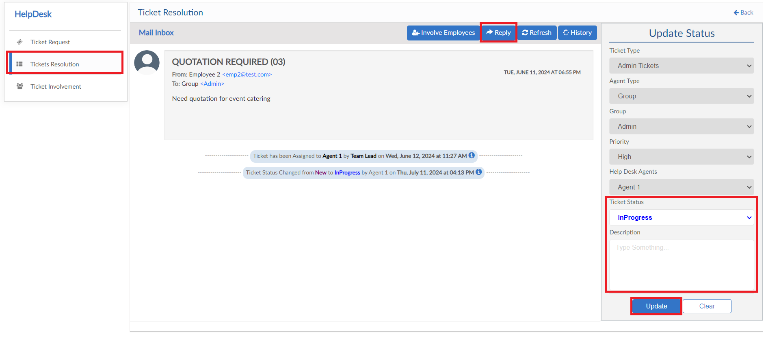
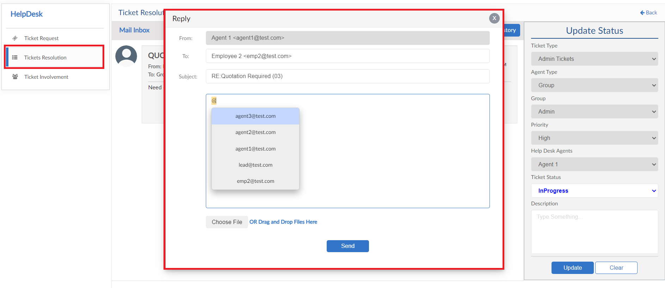
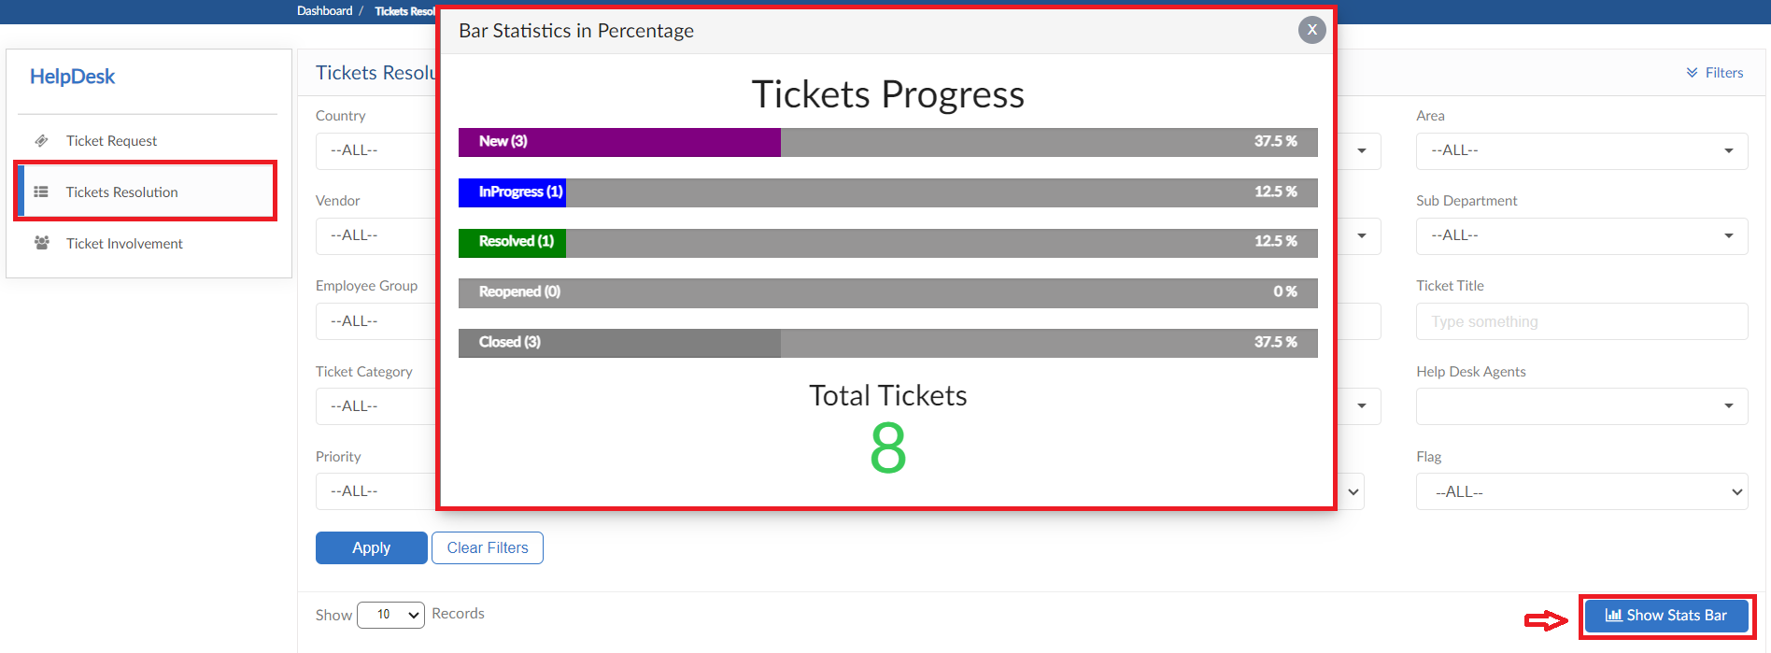

Ticket Involvement

- Moving to next tab that is Ticket Involvement
- Agent or Requester can involve any employee in the ticket as well
- Click on Involve Employee and Select employee from dropdown and a reason to involve
- After the employee is involved, the request will be seen in this screen
- Click on action button to view the ticket and perform required action
- Ticket screen show all this history of action
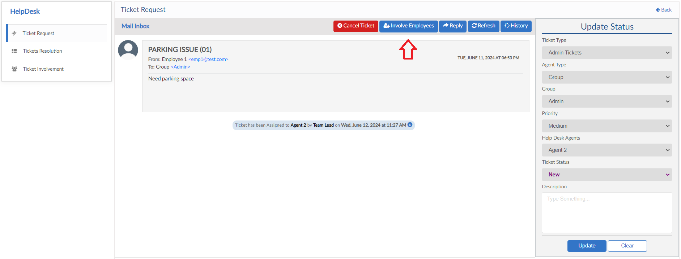
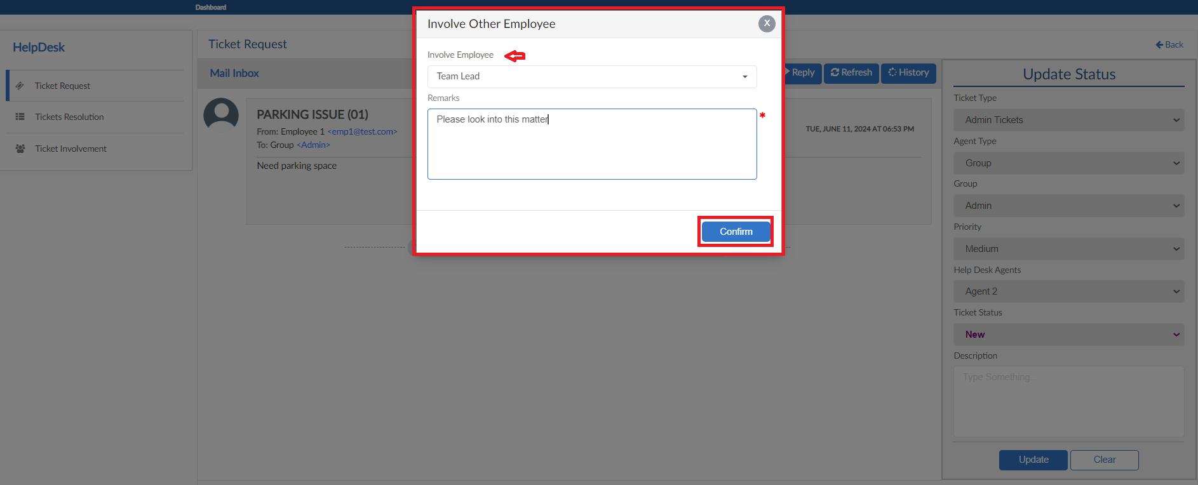
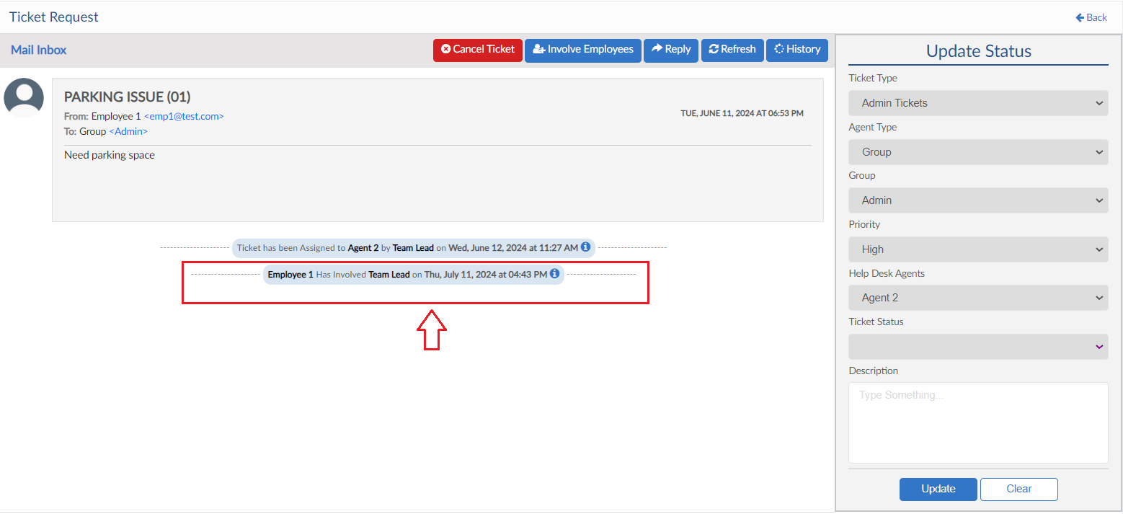

Helpdesk Setting

- Move to next Tab for Helpdesk Settings
- This screen includes multiple setting forms
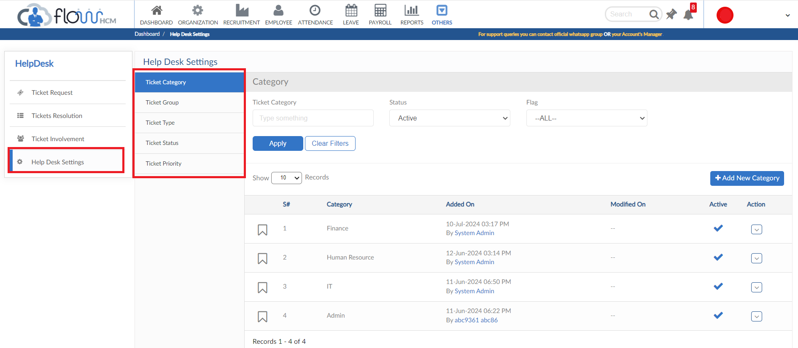

Ticket Category
- Click on Add new category button
- Enter Title of category, if required for agent user can allow to close the ticket after certain days apart from the employee
- And then click on save
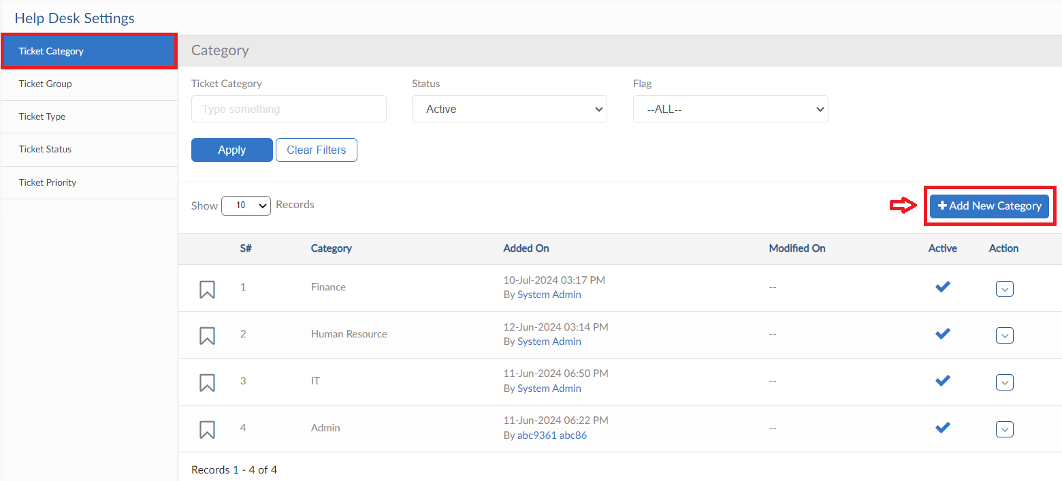
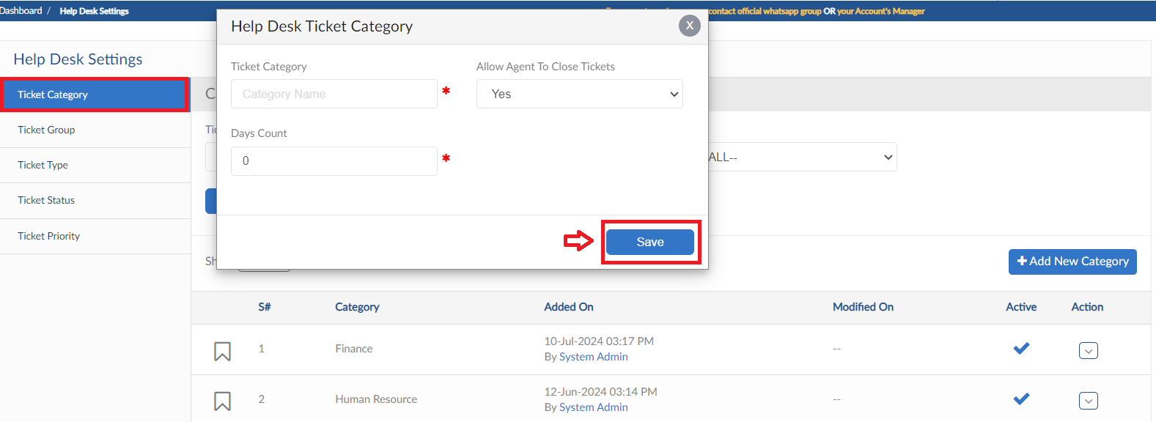

Ticket Group
- Click on Add new Group
- Enter Group Title, select the employees from dropdown to add in the group
- Mark a Group Lead from the selected employees and the click save button
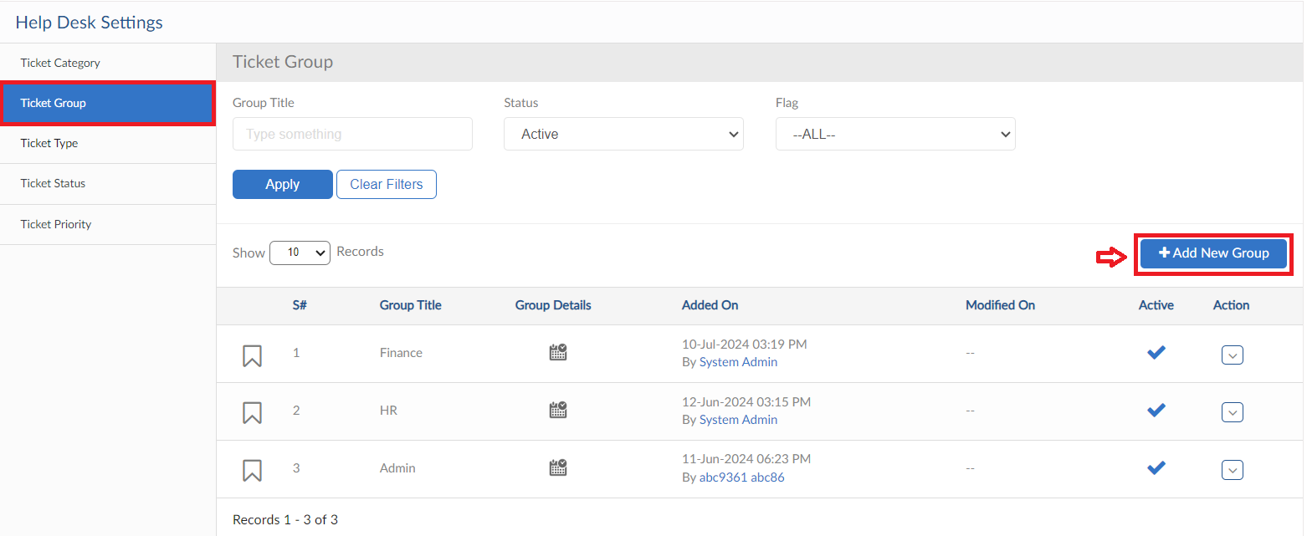
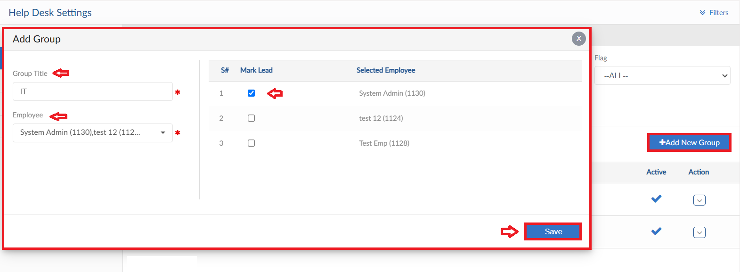

Ticket Type
- Click on Add New Type button
- Enter Ticket Type title and select category from dropdown
- Select Agent Type and filter the allowed employees to raise ticket for this type from Station, Department and Employee Group dropdowns
- If Agent type is set as Group then select the ticket group from dropdown as set parameters for ticket assign process
- User can set Target Hours to resolve tickets of this type to view the performance of agents
- Select the Employees to be Involved in a Ticket if required, only those will be seen in the ticket screen Involve dropdown
- In Notify Employees Via Email tab you can select the employees whenever the status of ticket changes will get notified
- Then click on Save button
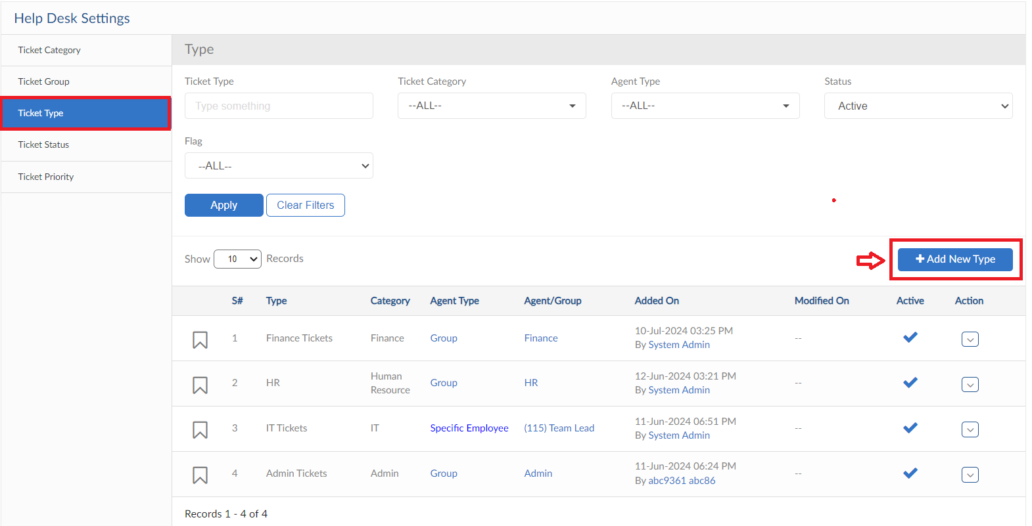
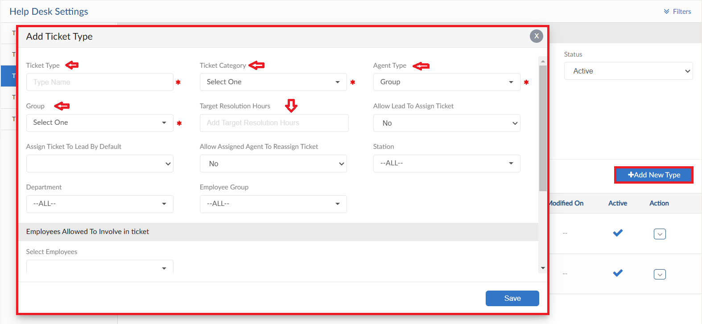
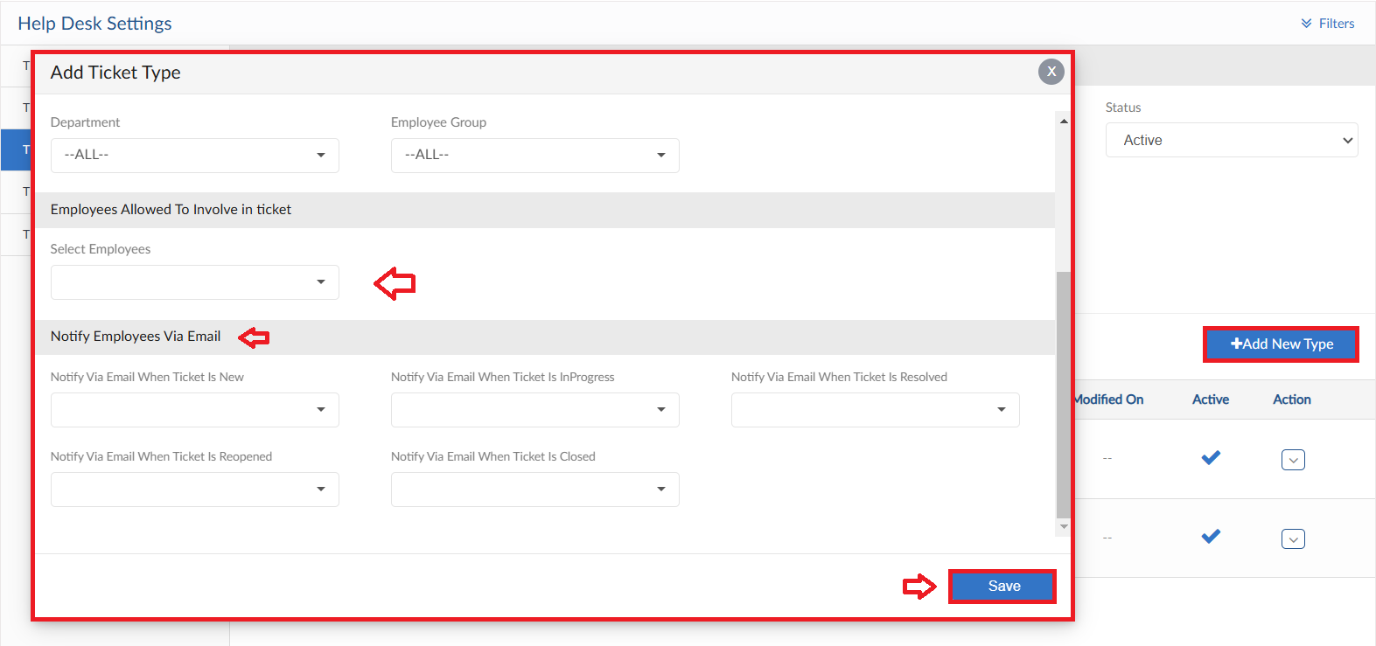

Ticket Status
- In this screen Status Titles can be changed as required
- Select the Status whose Titles need to be changed and then click on Save Settings button
- When required to reset all titles click on Reset to Default button
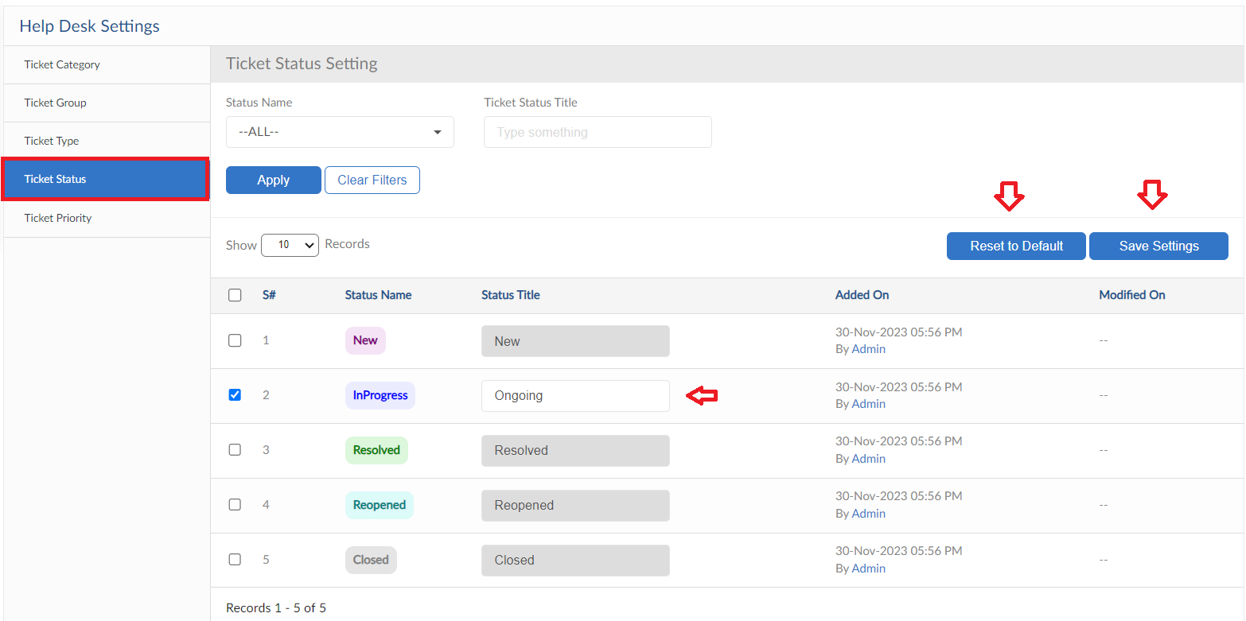

Ticket Priority
- In this screen Priority Titles can be changed as required
- Select the Priority whose Titles need to be changed and then click on Save Settings button
- When required to reset all titles click on Reset to Default button
